Manual I´ll Survive

Welcome, this is the User manual to a cool game made fully on python, here you will find all information you need to run and have a good time with our game, but please before proceeding, you must install some basic components:

This game is fully made in python and Tkinter, therefore we recommend anaconda as a good source of all modules you may need

First Steps:

#To intall the game:

#You must have python intalled in your computer!

if you dont have and want a very complete version of python 3.5 and GUIs:

follow this URL: https://www.continuum.io/downloads

if you want the game to work properly and have shared highscores:

must install firebase

therefore you must open your command prompt

if you dont know how to open your prompt:

follow this URL: http://www.digitalcitizen.life/7-ways-launch-command-prompt-windows-7-windows-8

after opening yor prompt tpe the following commands

"""

cd C:\your-game-folder\Magic-Trap\Firecall

python setup.py install

"""

#Congrats your game should be ready to launch

After installing you probably want to play the game right? So follow these steps to launch it:

1st option – Use the shortcut:

This is the easiest way to run the program, just go on the installation folder and click twice (or select and press enter) in the “MagicTrap.bat” file, don’t worry it is 100% harmless to your computer

It should have opened the game!

2nd option – trough console

Unfortunately we can predict how every computer open files (Linux, Mac) so here is another way opening the game:

1 – Open command console

2 – Use the command “cd c:\your game location\Gamefiles” to go to your game files folder in the console

3 – Type the command “Main.py”

It should have opened the game!

3rd option – trough Spyder (further documentation https://pythonhosted.org/spyder/)

if neither of those worked we recommend you to open a program that comes with Anaconda called Spyder then press “File” on the top left corner, then “Open”, search for the game installation file, go into Gamefiles and select “Main.py”

After that a small script should load on spyder screen, now go to a green arrow on the left corner of the screen and click it.

It should open the game!

Summary:

1. The Menu
2. GUI
3. Player
4. Board
5. Symbols on the Board
6. Ammo Display
7. Mechanics
8. Ranges
9. Timer
10. Conclusion

1 – The Menu:

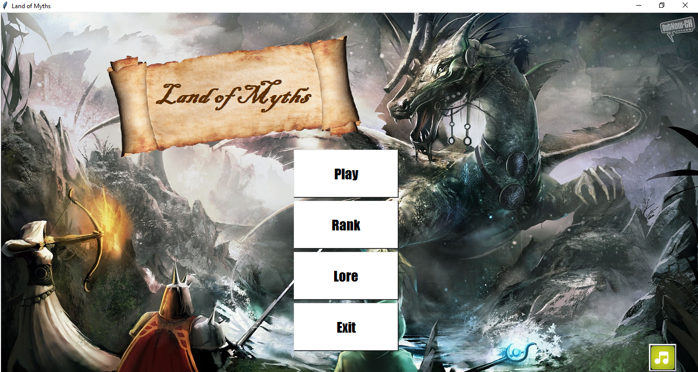

Buttons:

1 – Play = Starts the Game (Good Luck!)

2 – Rank = Pops a Rank of the top 5 players in the world! (go and Beat them!!!)

3 – Lore = Show you a short abstract of the world history.

4 – Exit = Leaves the Game (Don’t leave us ☹)

5 – Music Button = Switch music On and Off in the Menu

2 – GUI:

Waves Counter

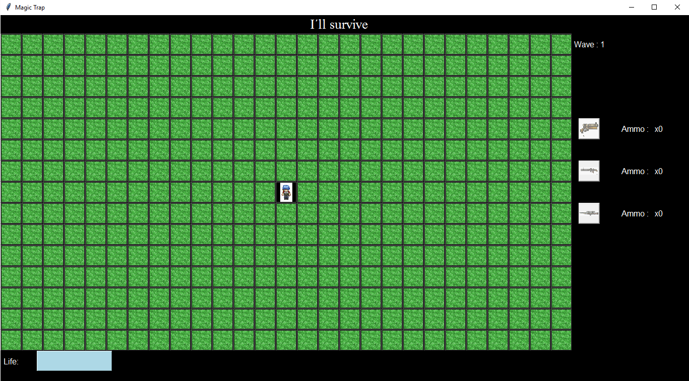

Ammo Display

Board

Life Bar

3 – Player:

The player is the character of the game, being controlled by the player through clicks on the board and key presses

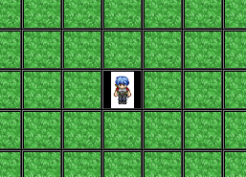

4 – Board:

The game board is a group of 27 X 15 buttons on it, through mouse clicks the player can perform actions such as walking, shoot and collect weapons.

5 – Symbols on the board:

 Pistol

 Shotgun

 Sniper Rifle

 Enemies

 Bosses

6 – Ammo Display:

The display, leave visible to the player the weapons that are unlocked, locked, and the ammunition that each one has.

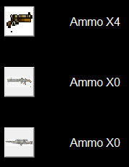

7 – Mechanics:

1 – Movement:

By pressing “W”, “A”, “S” or “D” you can move across the board, or “X” to skip your play

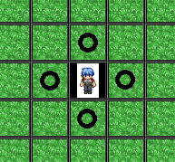

D

S

A

W

Pontos possíveis de movimentação

2 – Shoot:

In combat, if the player clicks on any enemy within range of your weapon the player will cause damage to this enemy and perhaps kill him 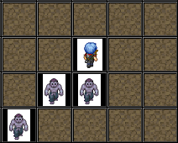

3 – Colect Itens:

When the player is close to an item he can move up on the item, collecting new weapons or ammunition

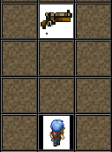

Item

4 – Enemies:

The enemies are monsters who chase the player trying to attack you. There are several types of enemies each with their respective life and power

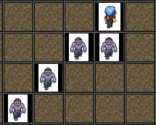

5 – Waves:

Once all the enemies were killed a new wave will be initiated, leading the p layer to new levels, bringing new enemies and increasing the score of the player.

6 – Weapon upgrades:

With the maximum amount of ammo, you can trade it for a +1 damage upgrade for your weapon, clicking on the “UP”. You may only do it once in a wave.

8 – Ranges:

The scope of a weapon determines how far an enemy can be hit by the shot, to enable range, simply click on the weapon selection button

1 – Pistol

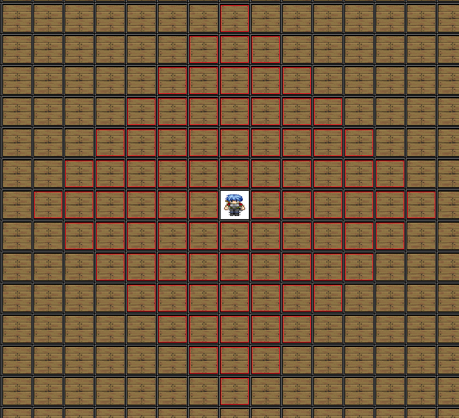

Linha de alcance da arma

2 – Shotgun:

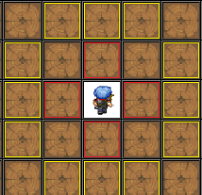

Dano colateral da arma

Linha de alcance da arma

3 – Sniper:

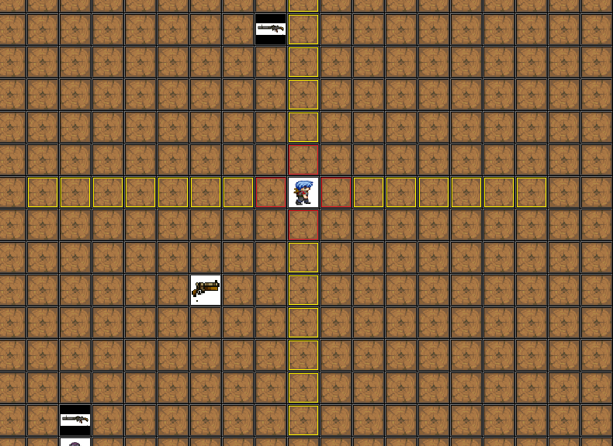

Dano colateral da arma

Linha de alcance da arma

9 – Timer

The timer is the craziest feature in the game, to make it more excited we decided to make it a timed game, you only have 2 seconds to make your move or the monsters will play regardless of you, muahahaha, be fast be smart, and good luck.

10 – Conclusion

Now that you learned everting you need to know to play, test your skill, face new Waves, bosses and beat the high scores, good luck

If you have any suggestions or doubts, contact us in this e-mail:

eduferrarimagalhaes@hotmail.com